4.3: The horizontal component of the force is 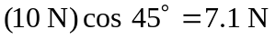 to the right and the vertical component is 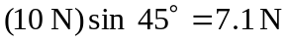 down.

